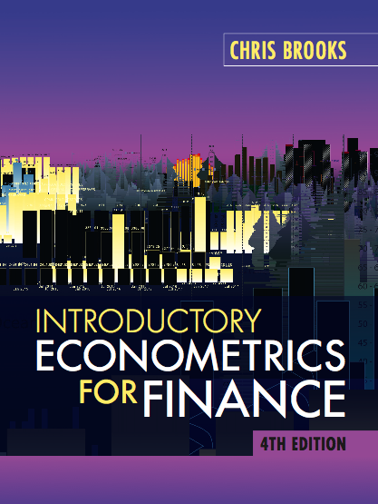
Solutions to the Review Questions at the End of Chapter 4

1. It can be proved that a t-distribution is just a special case of the more general F-distribution. The square of a t-distribution with T–k degrees of freedom will be identical to an F-distribution with (1,T–k) degrees of freedom. But remember that if we use a 5% size of test, we will look up a 5% value for the F-distribution because the test is two-sided even though we only look in one tail of the distribution. We look up a 2.5% value for the t-distribution since the test is two-tailed.

Examples at the 5% level from tables

T–k F critical value t critical value
20 4.35 2.09
40 4.08 2.02
60 4.00 2.00
120 3.92 1.98

2. (a) H₀ : β₃ = 2
We could use an F- or a t- test for this one since it is a single hypothesis involving only one coefficient. We would probably in practice use a t-test since it is computationally simpler and we only have to estimate one regression. There is one restriction.
(b) H₀ : β₃ + β₄ = 1
Since this involves more than one coefficient, we should use an F-test. There is one restriction.
(c) H₀ : β₃ + β₄ = 1 and β₅ = 1
Since we are testing more than one hypothesis simultaneously, we would use an F-test. There are 2 restrictions.
(d) H₀ : β₂ =0 and β₃ = 0 and β₄ = 0 and β₅ = 0
As for (c), we are testing multiple hypotheses so we cannot use a t-test. We have 4 restrictions.
(e) H₀ : β₂β₃ = 1
Although there is only one restriction, it is a multiplicative restriction. We therefore cannot use a t-test or an F-test to test it. In fact we cannot test it at all using the methodology that has been examined in this chapter.

3. THE regression F-statistic would be given by the test statistic associated with hypothesis (iv) above. We are always interested in testing this hypothesis since it tests whether all of the coefficients in the regression (except the constant) are jointly insignificant. If they are, then we have a completely useless regression, where none of the variables that we have said influence y actually do. So we would need to go back to the drawing board!

The alternative hypothesis is
H₁ : β₂ ≠ 0 or β₃ ≠ 0 or β₄ ≠ 0 or β₅ ≠ 0
Note the form of the alternative hypothesis: ‘or’ indicates that only one of the components of the null hypothesis would have to be rejected for us to reject the null hypothesis as a whole.

4. The restricted residual sum of squares will always be at least as big as the unrestricted residual sum of squares i.e.,
RRSS ≥ URSS
To see this, think about what we were doing when we determined what the regression parameters should be: we chose the values that minimised the residual sum of squares. We said that OLS would provide the ‘best’ parameter values given the actual sample data. Now when we impose some restrictions on the model, so that they cannot all be freely determined, then the model should not fit as well as it did before. Hence the residual sum of squares must be higher once we have imposed the restrictions; otherwise, the parameter values that OLS chose originally without the restrictions could not be the best.

In the extreme case (very unlikely in practice), the two sets of residual sum of squares could be identical if the restrictions were already present in the data, so that imposing them on the model would yield no penalty in terms of loss of fit.

5. The null hypothesis is H₀ : β₃ + β₄ = 1 and β₅ = 1
The first step is to impose this on the regression model
y_{t} = β₁ + β₂x_{2t} + β₃x_{3t} + β₄x_{4t} + β₅x_{5t} + u_{t} subject to β₃ + β₄ = 1 and β₅ = 1.
We can rewrite the first part of the restriction as β₄ = 1 - β₃
Then rewrite the regression with the restriction imposed
y_{t} = β₁ + β₂x_{2t} + β₃x_{3t} + (1-β₃)x_{4t} + x_{5t} + u_{t}
which can be re-written
y_{t} = β₁ + β₂x_{2t} + β₃x_{3t} + x_{4t} - β₃x_{4t} + x_{5t} + u_{t}
and rearranging
(y_{t} – x_{4t} – x_{5t} ) = β₁ + β₂x_{2t} + β₃x_{3t} - β₃x_{4t} + u_{t}

(y_{t} – x_{4t} – x_{5t}) = β₁ + β₂x_{2t} + β₃(x_{3t} –x_{4t})+ u_{t}

Now create two new variables, call them P_{t} and Q_{t}
p_{t} = (y_{t} - x_{3t} - x_{4t})
q_{t} = (x_{2t} -x_{3t})
We can then run the linear regression
p_{t} = β₁ + β₂x_{2t} + β₃q_{t}+ u_{t} ,
which constitutes the restricted regression model.

The test statistic is calculated as ((RRSS–URSS)/URSS)*(T–k)/m
In this case, m=2, T=96, k=5 so the test statistic = 5.704. Compare this to an F-distribution with (2,91) degrees of freedom, which is approximately 3.10. Hence we reject the null hypothesis that the restrictions are valid. We cannot impose these restrictions on the data without a substantial increase in the residual sum of squares.

6. r_{i} = 0.080 + 0.801S_{i} + 0.321MB_{i} + 0.164PE_{i} – 0.084BETA_{i}
(0.064) (0.147) (0.136) (0.420) (0.120)
1.25 5.45 2.36 0.390 –0.700

The t-ratios are given in the final row above, and are in italics. They are calculated by dividing the coefficient estimate by its standard error. The relevant value from the t-tables is for a two-sided test with 5% rejection overall. T–k = 195; t_{crit} = 1.97. The null hypothesis is rejected at the 5% level if the absolute value of the test statistic is greater than the critical value. We would conclude based on this evidence that only firm size and market to book value have a significant effect on stock returns.

If a stock’s beta increases from 1 to 1.2, then we would expect the return on the stock to FALL by (1.2–1)*0.084 = 0.0168 = 1.68%.
This is not the sign we would have expected on beta, since beta would be expected to be positively related to return, since investors would require higher returns as compensation for bearing higher market risk.

We would thus consider deleting the price/earnings and beta variables from the regression since these are not significant in the regression - i.e., they are not helping much to explain variations in y. We would not delete the constant term from the regression even though it is insignificant since there are good statistical reasons for its inclusion.

7.
.

Note that we have not changed anything substantial between these models in the sense that the second model is just a re-parameterisation (re-arrangement) of the first, where we have subtracted y_{t–1} from both sides of the equation.

(a) Remember that the residual sum of squares is the sum of each of the squared residuals. So let’s consider what the residuals will be in each case. For the first model in the level of y
Now for the second model, the dependent variable is now the change in y
where is the fitted value in each case (note that we do not need at this stage to assume they are the same). Re-arranging this second model would give
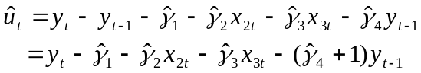
If we compare this formulation with the one we calculated for the first model, we can see that the residuals are exactly the same for the two models, with 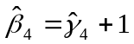 and 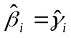 (i = 1, 2, 3). Hence if the residuals are the same, the residual sum of squares must also be the same. In fact the two models are really identical, since one is just a rearrangement of the other.

(b) As for R², recall how we calculate R²
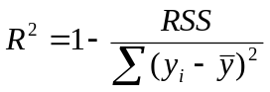 for the first model and

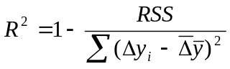in the second case. Therefore since the total sum of squares (the denominator) has changed, then the value of R² must have also changed as a consequence of changing the dependent variable.

(c) By the same logic, since the value of the adjusted R² is just an algebraic modification of R² itself, the value of the adjusted R² must also change.

8. A researcher estimates the following two econometric models
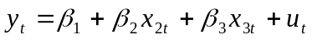
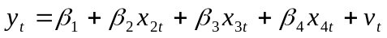
(a) The value of R² will almost always be higher for the second model since it has another variable added to the regression. The value of R² would only be identical for the two models in the very, very unlikely event that the estimated coefficient on the x_{4t} variable was exactly zero. Otherwise, the R² must be higher for the second model than the first.

(b) The value of the adjusted R² could fall as we add another variable. The reason for this is that the adjusted version of R² has a correction for the loss of degrees of freedom associated with adding another regressor into a regression. This implies a penalty term, so that the value of the adjusted R² will only rise if the increase in this penalty is more than outweighed by the rise in the value of R².

9. R² may be defined in various ways, but the most common is
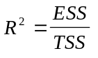
Since both ESS and TSS will have units of the square of the dependent variable, the units will cancel out and hence R² will be unit-free!

10. Quantile regressions represent a comprehensive way to analyse the relationships between a set of variables that involves constructing a family of regression models, each for different quantiles of the distribution of the dependent variable. Standard regression models effectively examine the relationship between a set of variables evaluated at the means of those variables whereas quantile regressions allow us to potentially examine the relationship between the variables across the whole of their distributions. They are far more robust to outliers and non-normality than OLS regressions in the same fashion that the median is often a better measure of average or ‘typical’ behaviour than the mean when the distribution is considerably skewed by a few large outliers. Quantile regression is a non-parametric technique since no distributional assumptions are required to optimally estimate the parameters.

11. No, this would not be a good way to proceed. By removing part of the sample in this way, effectively the researcher has truncated the sample, and the remaining part would suffer from severe selection biases. The results from this estimation would be at best very misleading. Using a quantile regression would probably do the job that the researcher wanted in a much more valid way and would not in fact involve using a sub-sample since all of the data are used in estimating all of the quantiles.

